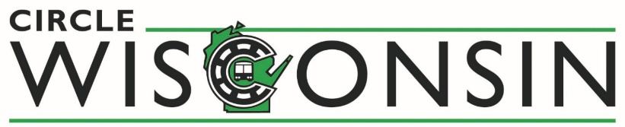
MEMBERSHIP APPLICATION
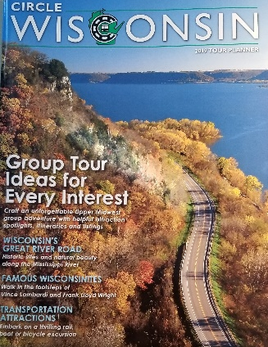
- CIRCLE WISCONSIN ANNUAL TOUR PLANNER DISTRIBUTED TO OVER 20,000 TOUR OPERATORS & PLANNERS THROUGHOUT THE US AND CANADA. ALSO AVAILABLE ONLINE ON CIRCLEWISCONSIN.COM AND LEISUREGROUPTRAVEL.COM
- CIRCLEWISCONSIN.COM – APPROXIMATELY 10,000 VISITS PER YEAR
- LEADS/PROSPECTS FROM OVER 10+ TOUR INDUSTRY TRADE SHOWS/EVENTS ATTENDED BY CIRCLE WISCONSIN
- MEMBERSHIP DUES ARE BILLED ANNUALLY 45 DAYS PRIOR TO ANNIVERSARY DATE
- ANNUAL CIRCLE WISCONSIN MIDWEST MARKETPLACE – MEET ONE-ON-ONE WITH OVER 30 TOUR OPERATORS FROM THROUGHOUT THE US & CANADA
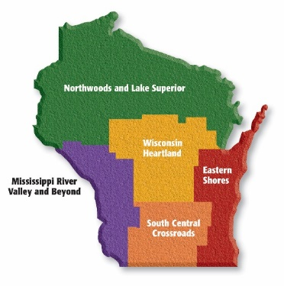
ALL MEMBERS WILL BE LISTED UNDER THEIR RESPECTIVE REGION.

PREMIER MEMBERS PLEASE CIRCLE ALL CATEGORIES THAT
BEST DESCRIBE YOUR ORGANIZATION
EASTERN SHORES | NORTHWOODS & LAKE SUPERIOR | WISCONSIN HEARTLAND | MISSISSIPPI RIVER & BEYOND | SOUTH CENTRAL CROSSROAD
RECEPTIVE & CHARTER | FESTIVALS/SPECIAL EVENTS | DINING | SHOPPING | LODGING
AG/FARMS | ATTRACTIONS/MUSEUMS | CASINOS | DESTINATION  DMO/CHAMBER | ENTERTAINMENT

Send your completed application and payment to:
Circle Wisconsin, PO Box 20750 Milwaukee, WI 53220
Send JPEG images to: wendy@circlewisconsin.com
Please Check Membership Level:

- Premier Membership $1,200
- Premier Membership (Museums) $600
- Associate Membership $600

- Festivals & Special Events $300
- Our organization has multiple properties- please fill out a form for each additional property at a cost of $700

Property or Attraction
Address
City State Zip
Phone ( ) Fax ( )
Website Email
Contact Person
Authorized Signature Date
Use other side to provide 50/25 word Organization Listing

MEMBER LISTING FOR CIRCLE WISCONSIN
GROUP TOUR PLANNER & WEBSITE
(50 words for Premier Membership / 25 words for Associate Membership)

INCLUDE WITH MEMBERSHIP APPLICATION OR EMAIL TO: wendy@circlewisconsin.com

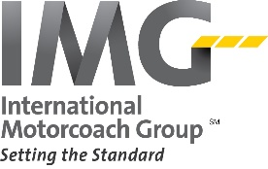
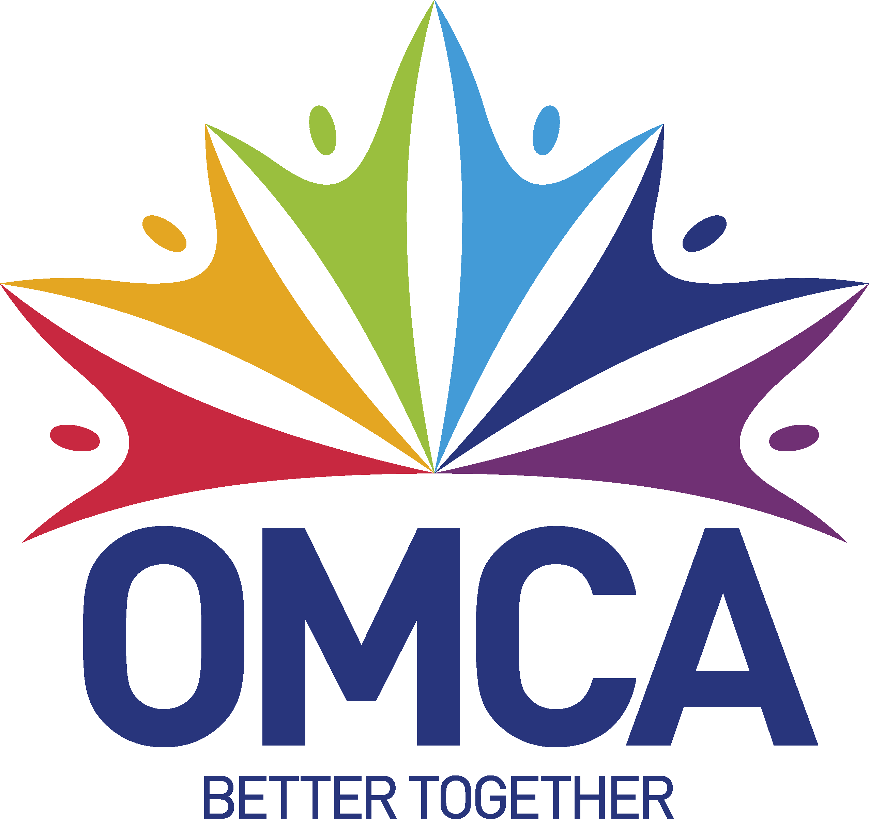
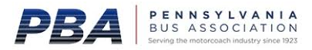
CIRCLE WISCONSIN IS PROUD TO BE A PARTNER/MEMBER WITH THE FOLLOWING ORGANIZATIONS

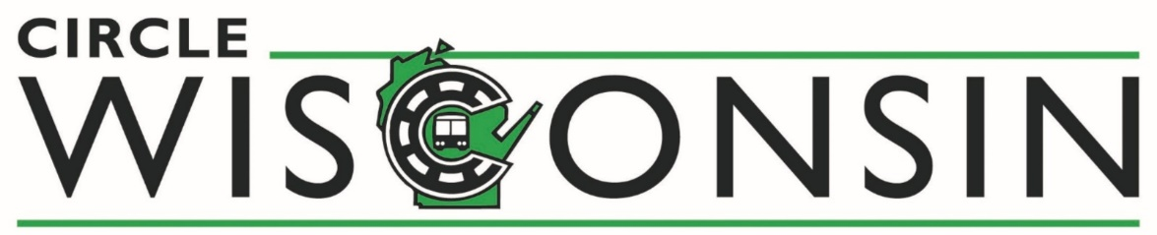
MEMBERSHIP INFORMATION
Circle WI has been marketing Wisconsin as a group tour destination since 1985.

Please choose the level of membership that meets your needs.

MEMBERSHIP  LEVELS & BENEFITS |  | PREMIER | PREMIER (NON-PROFIT MUSEUM) | ASSOCIATE | FESTIVAL/  SPECIAL EVENT
ANNUAL  MEMBERSHIP DUES |  | $1,200 | $600 | $600 | $300
MULTIPLE PROPERTIES  available only in conjunction with an initial Premier Membership |  | $700  PER ADDITIONAL PROPERTY
TOUR PLANNER LISTING  W/ FULL COLOR LOGO & CONTACT INFO |  | 50 WORDS | 50 WORDS | 25 WORDS | 50 WORDS
WEBSITE LISTING W/ IMAGE & CONTACT INFO | LISTING SIZE | 50 WORDS | 50 WORDS | 25 WORDS | 50 WORDS
 | HYPERLINK
 | EMAIL LINK
 | IMAGES | 5 | 5 | 3 | 3
 | CATEGORIES | REGION + | REGION + | REGION ONLY | REGION ONLY
PROMOTION AT
INDUSTRY EVENTS
ACCESS TO LEADS/PROSPECTS
EDUCATIONAL SEMINARS/
SALES MISSIONS
REDUCED REGISTRATION FOR THE ANNUAL
MIDWEST MARKETPLACE
CIRCLE WISCONSIN BOARD OF DIRECTORS ELIGIBILITY &
VOTING RIGHTS

